**Case: Bottle Cap 7**

Date: 04/12/2017

Team Member Names (list below)

Dayron

Johnson

Yezehao Huai

Li Mo

**A. Understanding the Case.**

**A.1. Flow Chart: On the following page**

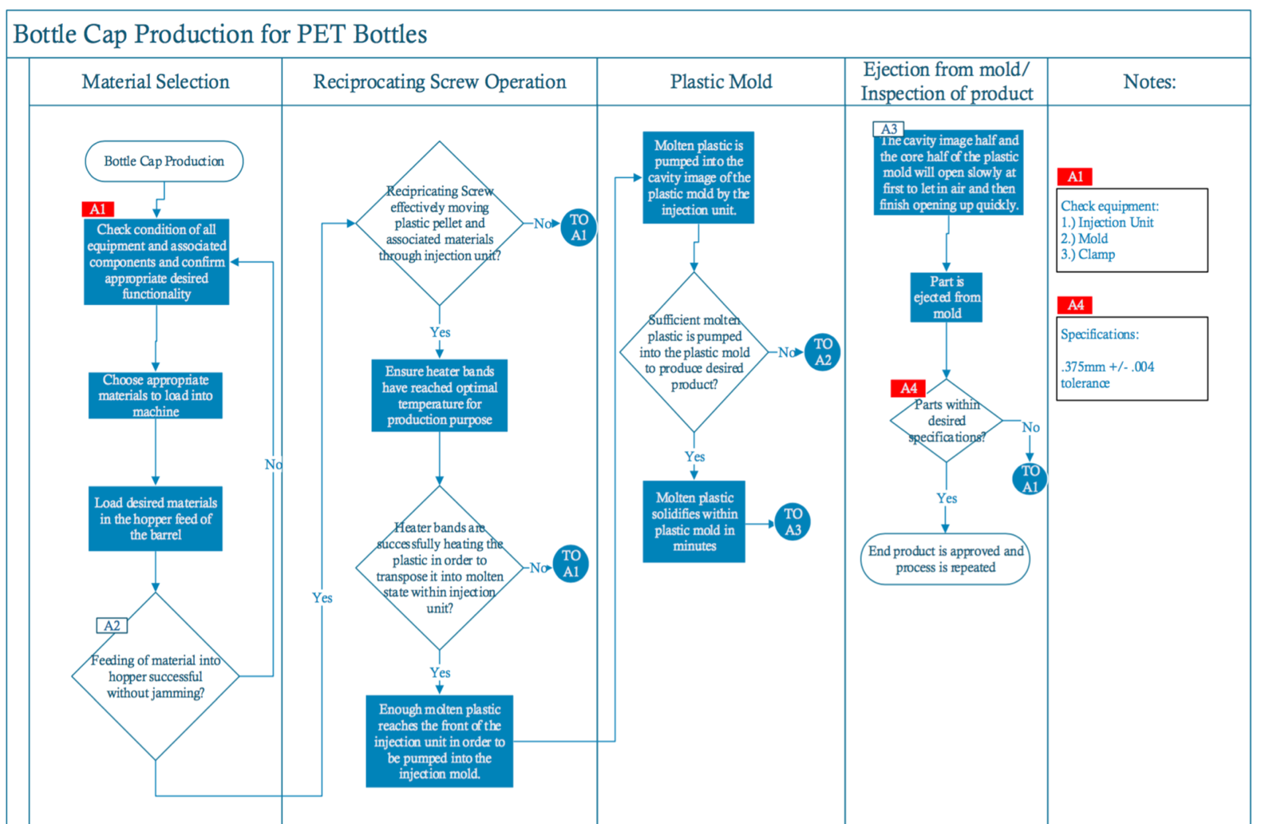

*Figure 1. Bottle Cap Production Flow Chart*

**B. Control Charts – Overall**

**B.1. Explain why you would want to monitor the process with control charts and how you will analyze charts once they are run. What conditions will you be looking for and what can you conclude from analyzing charts? (This is general discussion. Do not include your evaluation of the charts here.)**

A control chart is a process statistical control tool used to govern and ascertain whether a process should undertake an inspection for quality related glitches which may be caused by either special or common causes of variation. We are deciding the special cause condition in the process primarily because there have been customer complaints about the consistency of the diameter of our caps. If after analysis of the control charts is done and it is determined that the process is not in statistical control, action to alleviate the cause of variation and product quality needs to be taken by the administrator or controller.

The foremost step is to construct the R-Chart (Range chart). This chart is needed in order to produce an accurate **\bar x** bar chart. After constructing both charts one can see if the variation process is deemed “in control” or not.

The next step involves scrutinizing the trial limits by using the central theorem limit. Points plotted that are normally distributed are considered as a stable process. The prerequisite to look for in the **\bar x**bar charts are trends {upward trend (7 points continuously increasing) or downward trend (7 points continuously decreasing)}, cycles and shifts. When these trends occur, the process is said to be out of control which would then require action to be taken to ascertain the variation cause.

**B.2. Overall Data Control Chart**

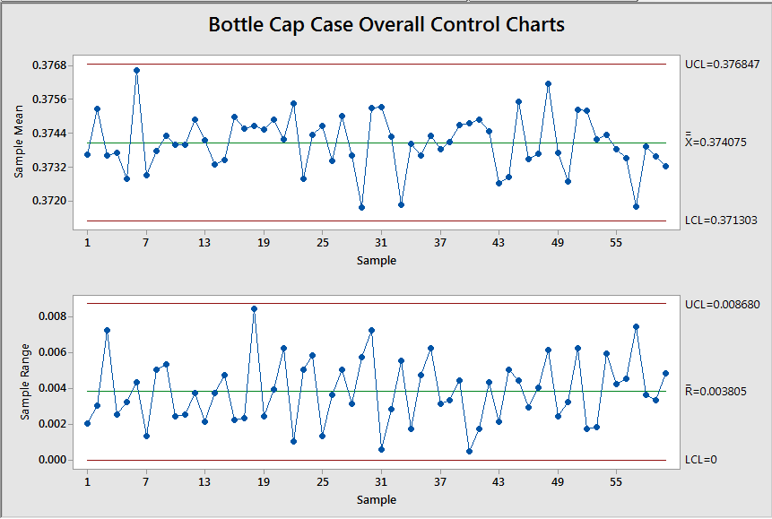

*Figure 2. Overall Control Chart*

**B.3. Analysis of Overall Control Chart: Findings and Conclusions.**

While analyzing the overall control chart, the trial limits are checked to see if the statistics follows a normal distribution. It is assumed that the ideal diameter to be examined will generate a pattern (according the central limit theorem) by a normally distributed random variable. Each sample must be independent and the procedural inspection is consistently applied from sample to sample. The process is viewed as unstable for any trend trend in thesample mean **\bar x** chart where 7 points are clearly seen to be above or below the sample mean. It may cause the improper cooling of the mold by the chiller. Therefore we need to find why these glitches are occurring and mitigate the issue in order to have a stable R chart and gain back statistical control of the process which in turn would optimize our manufacturing process.

**B.3. Explain the purpose of a capability analysis. Include assumptions required for use and explanations of Cp, Cpl, Cpu, and Cpk.**

The capability (Cp) is the 6σ range inherent process variation or a data set. To determine this value, one must find the difference between the upper specification limit (USL) and the lower specification limit (LSL) and then divide it by the calculated value of 6σ as demonstrated later on. If the process is centered and Cp is calculated to be greater than 1, then this indicates that our values are grouped close to one another but are not necessarily close to our target.

When calculating Cpu and Cpl, one must take μ (sample mean) and the upper and lower specifications into account. Cpu is for the upper specification so we subtract the sample mean from the upper specification and then divide but the value of 3σ. Similarly to determine Cpl one should use the lower specification and substract the sample mean and then divide by 3σ.

A process if defined to be centered or not by the calculated Cpk value. Cpk is a value which depicts how close the values of our data is to our desire target. The larger Cpk, the greater our data is centered to the desire values. Cpk can be defined as Cpk = min (Cpu, Cpl). Cpk must be greater than 1 for a process to be considered capable.

Control charts don’t necessarily tell us if a customer’s requirements are met, it tells us if a process is in statistical control (i.e. stable). The purpose of the capability analysis is to answer how well the requirement matches the desired specification for out high pressure molding manufacturing process. The process capability is gauged against the specification by using CPK (process capability index).

As stated earlier, CP given by the following equation:

Cp:

This is understood to be the process capability ratio. To determine the value the difference between USL and LSL is divided by the calculated 6σ.

If the process is centered and CP > 1, then a low number of uncharacteristic and abnormal products or items will be produced. If CP ˂ 1, this will indicate that uncharacteristic and abnormal products are being produced whether the process is centered or not.

Our CPU and CPL are given by the following equations respectively:

CPU= CPL=

CPU and CPL takes the mean and the upper and lower specifications into account.

Lastly, our CPK is the process capability ratio that takes into account centering and we are able to calculate our Cpk based on the following equation.

CPK = min (CPU, CPL)

CPK is an index that assesses how close a process is running to its specification limit, comparative to the process variability. CPK must be higher than 1 for the process to be considered capable. Using CPK and CP we can determine if the process is centered and capable or not in regard to the desired specifications.

**B.4. Overall Capability Analysis**

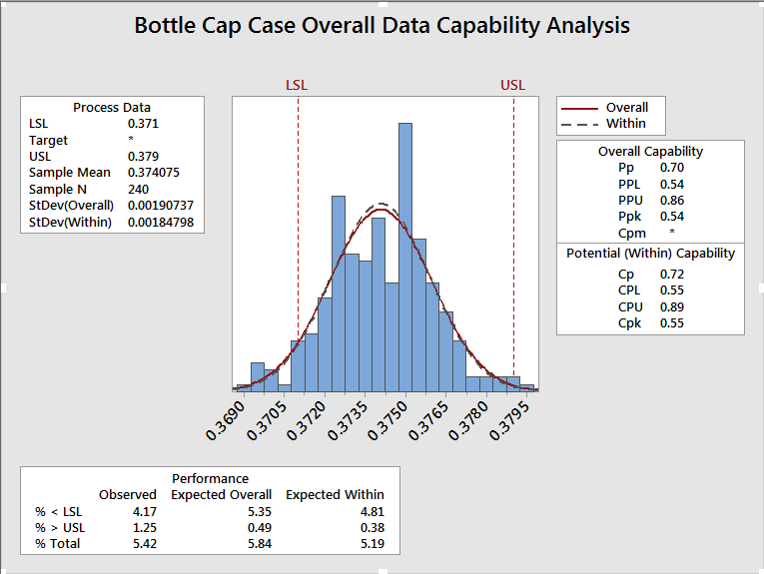

*Figure 3. Overall Data Capability Analysis*

**B.5. Based on the results of the overall capability analysis, what is the capability of the current process to hold the diameter? (discuss Cp, Cpu, Cpl and Cpk and describe what each tells about the process). Indicate the % out of specification and describe how this percentage relates to the indices.**

Given Ideal diameter for the bottle cap is 0.375mm with tolerance level of +/- 0.004. Our capability table variables are: n=4, d2=2.059. We can calculate our specified upper and lower limits using the following equations:

USL = (0.375+0.004) = .379

LSL = 0.371 (0.375-0.0040) = .371

After acquiring Ṝ from our control charts we can now determine our sigma values using the following equation:

σ = = 0.003805/2.059=0.001848

Using our USL, LSL, and σ we can now continue to determine our capability process ratio (Cp) with the following equation.

Cp= = = 0.72

CP is less than 1, indicating nonconforming, uncharacteristic and abnormal products are being fabricated and manufactured

We will now continue with determining our Cpu and Cpl.

CPU= = 0.89 CPL= = 0.55

We can now calculate our Cpk:

CPK=min (CPU, CPL)

CPK=min (0.89, 0.55) = 0.55

CPK must be greater than 1 for a process to be considered capable and proficient. Since CPK (0.55) is less than 1, the process is considered not proficient or capable.

.

Our ZLSL and ZUSL are determine below:

Z.LSL = -1.62 = .0526 , Z.USL = 2.705 = .9966

Using the values found in the Z-Table the total percent that are out of specification is:

0.0526+0.9966=1.0492%

This number can also be depicted as parts per million nonconforming =10492ppm.

As clearly seen, CP is greater than CPK, indicating the mean of the process is slightly curved to the left or closer to the lower specification than the upper specification limit. The Six-pack capability analysis from Minitab, therefore is needed to appraise the requirements for capability analysis

**C. Control charts – individual shifts.**

**C.1. Sixpack Charts per Shift (continued on following page.)**

*Figure 4. Bottle Cap Data by Shift: Shift Number1,2,3*

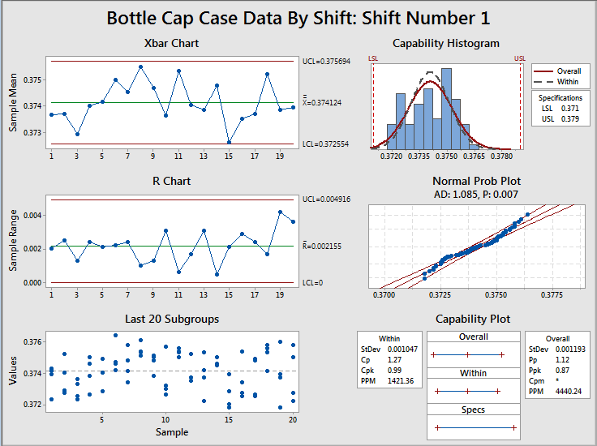

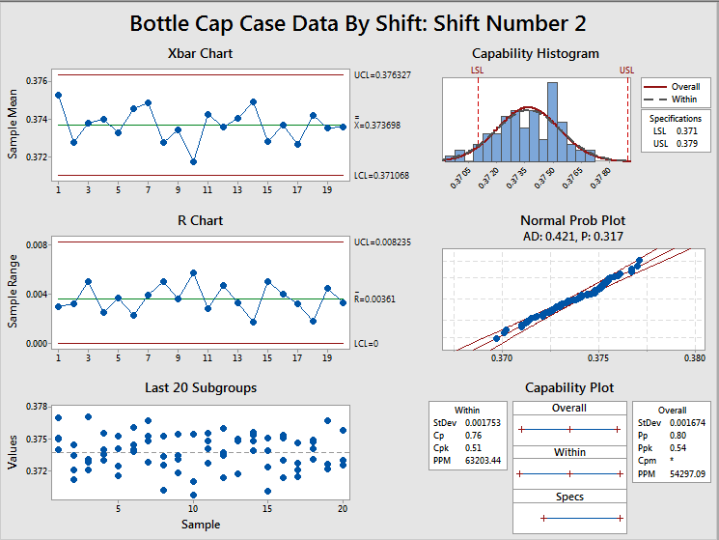 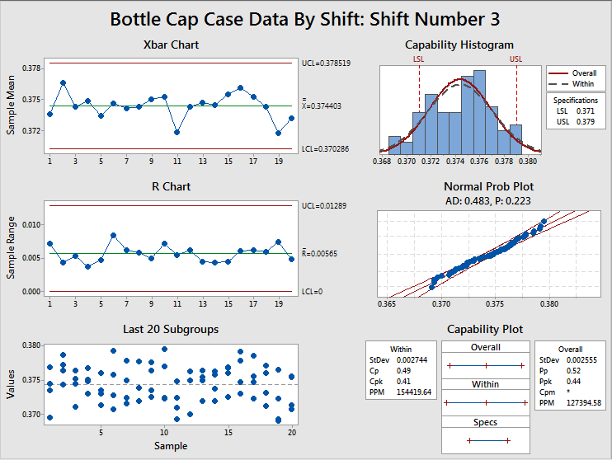

**C.2. Analyze and compare the three shifts’ control charts. Describe your findings and conclusions.**

After analyzing the sixpack charts for the three shifts, one can now see now see the data differently. Though shift 2 continues to show stable and controlled data set, shift 1 and 3 seem to show otherwise. Shift 1 shows a mild instability throughout points 5 to 9 as these four points are seen to above the sample mean continuously. A more drastic example is seen during shift 3 beginning on point 12 all the way through 18. When analyzing the control chart, these points continuously above the sample mean indicated instability in the data. Showing that shift three is the prominent data set which is creating the variability in our system. Shift 2 also contributes with is mild set of points above the sample mean.

**C.3. Analyze and compare the three shifts’ capability analysis. Describe your findings and conclusions.**

Our capability analysis suggests that as the shift number grows, the Cpk and Cp decrease overall. As these numbers decrease the ppm value increases accordingly during each shift. Shift 2 has a ppm of 54197.09 and shift 3 boasts a ppm of 127394.58.

Shift 1 indicates a Cpk of .99. Though it is not greater than one, it is far greater than the Cpk for the following shifts. Shift 2 has a Cpk of .51 and shift 3 has a Cpk of .41. With this capability analysis we can conclude that as the shift progresses throughout the day, the quality of the work deteriorates along with it. The best course of action would be to investigate the reason why this phenomenon is occurring during the later shifts of the day and proceed accordingly.

**D Temperature versus Diameter**

**D. 1 Paste the scatter diagram of temperature versus diameter here.**

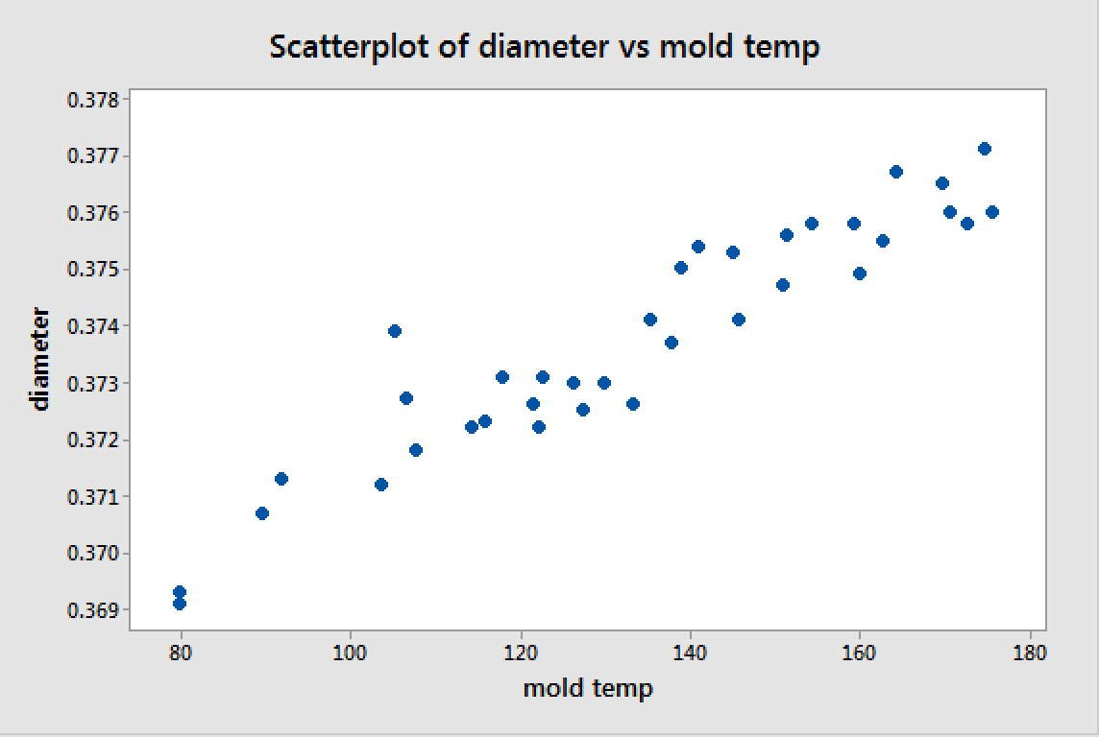

*Figure 5. Minitab output scatter diagram*

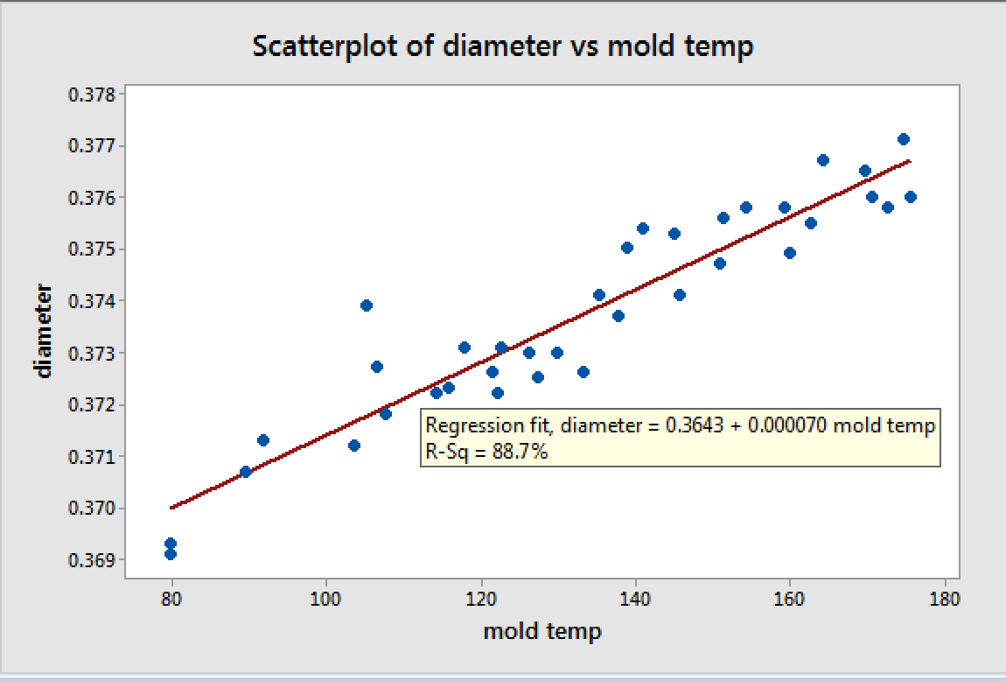

*Figure 6. Minitab Output Regression Analysis*

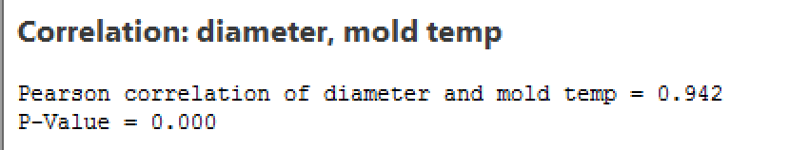

*Figure 7. Minitab Output Correlation*

**D.2. Describe your conclusions in analyzing the scatter diagram. Discuss how can you use this information?**

From the scatter diagram,

Regression fit, diameter=0.3643+0.000070mold temp

R-Sq=88.7%

From the scatter diagram, the regression line slopes upward from left to right, the slope of the regression line is 0.000070, and the correlation of diameter and mold temp is 0.942. So, we can get the positive correlation relationship between diameter and mold temp. If the mold temp increase 1, the average diameter will increase 0.000070.

How can we use this information?

First, we can use this information to deserve the mold temp and the monitoring of mold temp in refrigeration is important. If we can control the mold temp in stably, we can increase the accuracy of the diameter.

Second, the data of the scatter diagram reveal that when mold temp is 152.86, the diameter is 0.375mm which is closest with the ideal diameter for the bottle caps, so we can cut short the mold temp monitoring scope. (0.375=0.3643+0.000070mold temp, we get mold temp=152.86).

**E Gage R&R**

**E.1. “Report for Measurement” output from the Gage R&R. (Xbar/R on this page. ANVOS on next)**

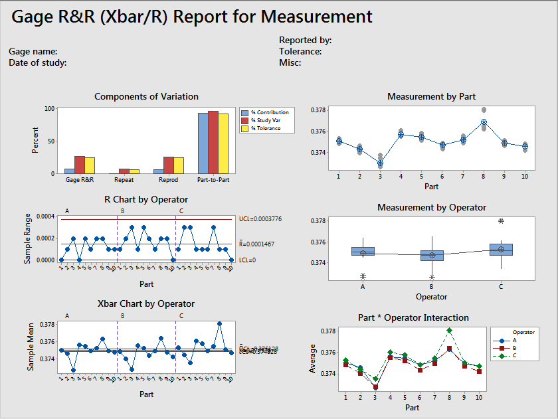

*Figure 8. Gage R&R*

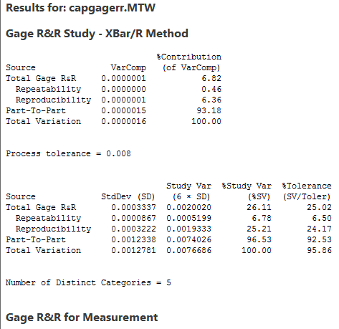

*Figure 9. Minitab Output Gage R&R-XBar/R Method*

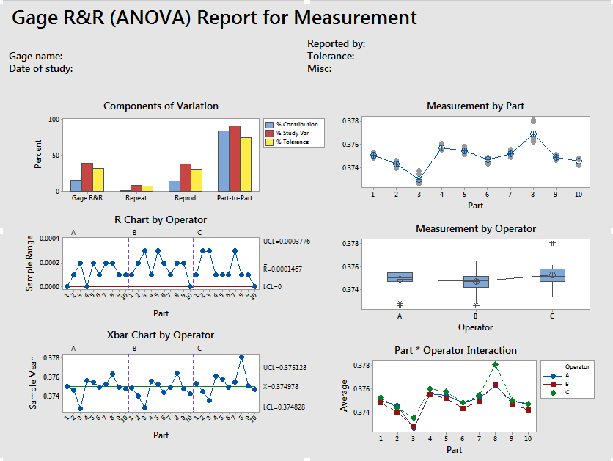

*Figure 10. Gage R&R(ANOVA)*

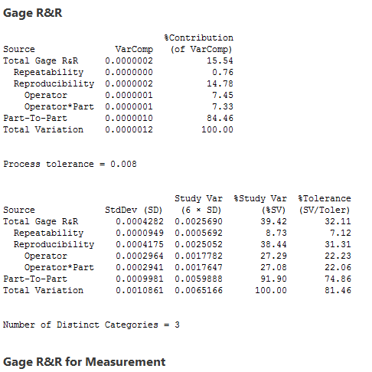

*Figure 11. Minitab Output Gage R&R*

**E.2. Explain what the repeatability and reproducibility data from the study indicate. Explain any significant observations in the Report and Measurement charts.**

The reproducibility (also known as appraiser variation) of the data shows the measurement variation that may occur due to differences between operators using the same instrument to measure a specific part. Repeatability (also known as equipment variation) study indicates the variability in measurements obtained using the same instrument as it is used several times to measure the same part.

If our GRR or Tolerance percentage falls below 10, then it may be acceptable. If the percentages are between 10-30%, it may be acceptable depending on the application. Lastly, if our percentages come out greater than 30%, then we can conclude that our system needs some improvement.

Some of the observations from our X-Bar/R suggest a repeatability of 6.78% and a reproducibility of 25.21%. The number of distinct categories is 5. Based on these values our %GRR is 26.11%. From these values we can conclude that our reproducibility is the area where the most improvement is needed. In order to improve reproducibility, possible retraining of the operators may be recommended.

**E.3. Is the %GRR measurement system acceptable per the MSA Guidelines? Explain.**

Based on the %GRR calculated value of 26.11%, our system may be acceptable as per the MSA guidelines. The %GRR range between 10% and 30% is the range where other factors must be considered in order to decide whether the process if acceptable or if it needs improvement.

**E.4. What does the % study variance to tolerance tell you?**

Our % study variance to tolerance is calculated to be 25.02%. This may also be acceptable using the MSA guidelines depending on its application. We use our tolerance when deciphering measurements of parts in correlation to the desired specification. A high tolerance percentage tells us that the measurement tool or system used is not very effective due to the high variation of measurements presented in our data as demonstrated by the high percentage we are seeing in our study.

**F. Causes of variation**

**F.1. Causes of variation diagram: Why-Why Diagram**

*Figure 12. Why-Why Diagram*

**F.2. Based on the analysis so far, what are the primary causes of variation in the process? Explain.**

Based on our “why-why” diagram analysis, we can conclude that the two biggest causes of variation in our process could be Operator and Machine related.

The operator must be well qualified and optimally trained to use and maintain the machine effectively and efficiently. The company can focus on increasing the quality and intensity of the training regime prescribed to employees within the company. The operator must remain vigilant with the task at hand as well with the maintaining and upholding the integrity of the equipment. If possible, the operator should also be supervised by some type of lead to ensure there are no distractions in the working environment. The operator may also be working under time pressure or possible illness which may decrease overall performance throughout the shift.

Similarly, the Machine may be the cause of the variation due to regular wear and tear or a possible unexpected and/or catastrophic damage. There are different components which are crucial to the process of producing the bottle caps. If one of these crucial components begins to malfunction, it will directly affect the remaining components as well as produce an undesired product. The company should prioritize the maintenance of the machine at regular intervals to ensure that all components associated with the process are working as desired. From our analysis, we can conclude that if all liable aspects related to operator and machine are mitigated, there will be fewer causes of variation within the production overall.

Additional causes of variation in the process can be deduced to be the temperature deviation and discrepancies. Ideal or optimum conditions for running the chiller cannot be guaranteed because the encircling or surrounding temperature cannot be controlled. Therefore the injection molding process is highly sensitive to the cooling competence of the chiller and the temperature.

**G. Short term process recommendations**

**G. Based on the analysis thus far (all parts), what recommendations do you have for the process? Make at least three specific recommendations. State the recommendation, and then give the reason for the recommendation citing the data from the analysis. (Each recommendation in its own paragraph.**

Analyzing our control charts and studying our capability analysis, there is a distinct difference in variation among the 3 shifts. Throughout the day there are multiple variables that could contribute to the variance in our process. Below we will provide three short term recommendations that could help us center our process.

Recommendation 1: Process

In order to fully determine if there is something wrong with any of the variables incorporated in our process, we must first verify that our specifications are feasible and overall repeatable using proper techniques. After verification of the overall desired specifications, it maybe be recommended to follow this study with auditing training techniques and programs which may be causing misunderstandings among the employees and the processes. As a follow up to this study, we would recommend to create a Pareto chart (per shifts and overall) to identify defect types and the most common variation causes for each induvial shift and for overall process.

Recommendation 2: Equipment

Equipment maintenance should be prioritized and evaluated to ensure that the equipment is working optimally. It should be verified that each part of the equipment is operating to specification. A specific portion of the equipment that should be extensively verified is the temperature of the mold. The temperature of the mold and heating pads during both heating and cooling phases is crucial. This should be closely monitored (needs to be around 152.86oF- From D analysis) and observed as we can safely say that the diameter of the of the bottle caps is dependent on the temperature of the mold, therefore to fix this, the chiller cooling capacity and the surrounding temperature is to be adjusted regularly so that the entire process produces the needed specification caps.

Recommendation 3: Operator

The measurement performed by the operators (Part E) is also a source of variation as indicated in the measurement system analysis. Proper instructing and training on the equipment use is therefore highly recommended.

**H. Capability after improvements**

**H.1. “After” Control Charts**



*Figure 13. “after” Control Chart*

**H.2. Analyze the control charts and describe your findings and conclusions.**

After data improvement, there are no points out of the control limits or shift. No more than 7 points in a row increasing or decreasing. We can safely say that the process has become more stable after improvement and also that the limits were inaugurated based on a stable process.

**H.3. “After” capability analysis here.**



*Figure 14. “after” Capability Repot*

**H.4. Analyze the Capability Analysis and describe your findings and conclusions.**

From the above representation of ours after capability report, the process now seems stable with data from a normally distributed population. The capability analysis and conclusions is as follows:

CP ˃ 1: Indicates that a low or small number of uncharacteristic, nonconforming or abnormal products is now being produced by the process.

CPL ˃ CPU: While taking the mean, along with the upper and lower specifications into account. The process is considered more centered towards the lower specification limit.

CPK ˃ 1 : Lets us know that the process is considered capable. A hypothesis test is also needed to confirm the assumption.

**I. Statistical Significance of Changes**

**I.1. At a 95% level of confidence, can you conclude there has been a reduction in the variance before (all operators) and after (improved data). Comment on the strength of the conclusion. Paste in Minitab output and discuss.**

**Descriptive Statistics: after**

Variable N N* Mean SE Mean StDev Minimum Q1 Median Q3 Maximum

after 100 0 0.37525 0.000119 0.00119 0.37162 0.37439 0.37520 0.37613 0.37799

**Test and CI for Two Variances**

Method

Null hypothesis Variance(First) / Variance(Second) = 1

Alternative hypothesis Variance(First) / Variance(Second) > 1

Significance level α = 0.05

F method was used. This method is accurate for normal data only.

Statistics

95% Lower

Bound for

Sample N StDev Variance Variances

First 240 0.002 0.000 0.000

Second 100 0.001 0.000 0.000

Ratio of standard deviations = 1.604

Ratio of variances = 2.574

95% One-Sided Confidence Intervals

Lower Bound Lower Bound

for StDev for Variance

Method Ratio Ratio

F 1.389 1.929

Tests

Test

Method DF1 DF2 Statistic P-Value

F 239 99 2.57 0.000

*Figure 15. Minitab Output Test of CI and Variances*

The null hypothesis is at 95% level of confidence. It can also be understood that the variance before (all operators) and after (improved data) have no difference. The alternative hypothesis is there has been a reduction in the variance before (all operators) and after (improved data).

Variance (First) is “before” and Variance (Second) is “after”. StDev of “before” is 0.00191 greater than StDev of “after” that is 0.00119. Ftest is 2.57, higher than 1. The p-value of 0.000 is lower than α = 0.05. Therefore we can conclude that the null hypothesis is rejected.

The alternative hypothesis that there has been a reduction in the variance before (all operators) and after (improved data) by the changes made is plausible.

In practical terms, the “after” process is effective at reducing the process variance which can be understood to mean the new process is more stable.

**I.2. At a 95% level of confidence, what conclusion can you draw about the process mean before (all operators) and after (improved data). Paste in Minitab output and discuss.**

**Two-Sample T-Test and CI**

Sample N Mean StDev SE Mean

1 100 0.37525 0.00119 0.00012

2 240 0.37407 0.00191 0.00012

Difference = μ (1) - μ (2)

Estimate for difference: 0.001171

95% CI for difference: (0.000834, 0.001508)

T-Test of difference = 0 (vs ≠): T-Value = 6.84 P-Value = 0.000 DF = 287

*Figure 16. Minitab Output Test of CI and T-Test*

The null hypothesis is at a 95% level of confidence. From our data we notice that the process mean before (all operators) and after (improved data) have no difference. The alternative hypothesis suggest that the two means are different. The P-Value-0.000, so we can reject the null hypothesis. Therefore, we can conclude that at 95% confident level of confidence, the assumption that the process mean before and after are different. In practical terms, it means the “after” process changed the capability.

**J. Long Term Recommendations**

**J.1. Provide a specific recommendation relative to further reducing variation in the process. State the recommendation and refer to previous aspects of the case/analysis in giving reasons for the recommendation.)**

Recommendation:

To further reduce the variation in the process, the company should increase equipment maintenance predominantly with temperature actualization. Prioritizing the maintenance, will ensure it is operating at peak performance and temperature throughout the entire day regardless of the shift. The company can increase the budget for machine maintenance. After prioritization of maintenance tasks, the company should collect data and run the same analysis we had run. Running this same study will allow us to confirm that variability has decreased as we have corrected the true cause of variation within our process.

Reason:

From our flowchart we can narrow down the problem to have something to do with the equipment itself. Additionally, after analysis our scatter plot, we can further understand that the temperature has a linear relation to the bottle cap size. As temperature increases, so does the bottle cap size. Using our scatter plot we can begin to rule out that the equipment is operating mechanically incorrect and that all the specifications are feasible. Instead we can concentrate our efforts and resources and direct them into ensuring that the temperature of the mold and heating pads are at desired values throughout all the shifts.

**J.2. Provide a specific recommendation for continued monitoring of the injection molding process. Describe the steps needed to implement the recommendation.**

As we continue to monitor our injection molding process, we should depend on the control chart and the capability analysis to determine if our variance has decreased. The company should focus efforts on maintaining optimal temperature of the mold throughout the entire process. Maintaining the best temperature possible will allow us to meet the desired specifications. We recommend to fulfill this effort by conducting periodic studies.

Overtime, we recommend collecting various batches of bottle cap diameters to ensure that we are meeting our desired specifications. With this data we should create control charts and capability analysis studies. Doing these preliminary studies will allow us to know if any equipment maintenance or process modification is once again required based on the calculated Cp (capability) and Cpk(centering). If our process once again is deemed to be “not centered” or “not capable” we would recommend first producing a study based on temperature of the mold against bottle cap size. (In the part H “After” capability analysis, we get the new Cpk (1<Cpk=1.03<1.2). It means that process is barely capable and the company should take more effort to further improve the process to pursuit a Cpk which greater than 1.3).

In order to establish these periodic studies, proper and standardized training must be introduced throughout the company in order to realize signs of equipment malfunctioning by all of operators during any shift of the day. This can be accomplished by introducing procedures which will mitigate such variance in the products throughout the shifts. Applying this knowledge across all the appraisers and shifts, we will be able to catch variances when they occur and reduce overall variability in our process.